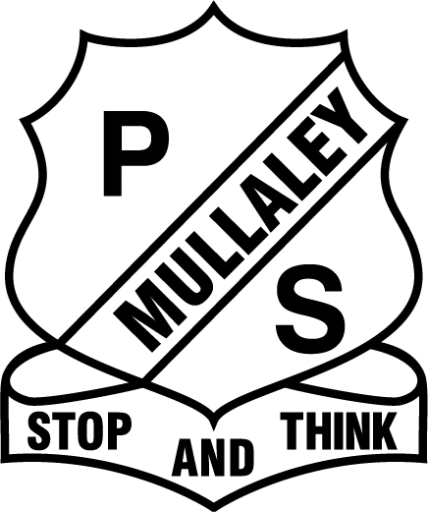
MULLALEY PUBLIC SCHOOL

General Permission to Publish and disclose information

Dear Parent/ Caregiver,
I am seeking your permission to allow the school/Department of Education to publish and/or disclose information about your child for the purposes of sharing his/her experiences with other students, informing the school and broader community about school and student activities and recording student participation in noteworthy projects or community service.

This information may include your child’s name, age, class and information collected at school such as photographs, sound and visual recordings of your child, your child’s work and expressions of opinion such as in interactive media.

The communications in which your child’s information may be published or disclosed include but are not limited to:
- Public websites of the Department of Education including the school website, the Department of Education intranet (staff only), blogs and wikis
- Department of Education publications including the school newsletter, annual school magazine and school report, promotional material published in print and electronically including on the Department’s websites
- Official Department and school social media accounts on networks such as YouTube, Facebook and Twitter
- Local and metropolitan newspapers and magazines and other media outlets

Parents should be aware that when information is published on public websites and social media channels, it can be discoverable online for a number of years, if not permanently. Search engines may also cache or retain copies of published information. Published information can also be linked to by third parties.

Please complete the permission slip and return to the school by Tuesday 4th February.

Yours sincerely
Benjamin Carter
Principal
30th January, 2020

Permission to Publish
I have read this permission to publish and:

Tick the appropriate box
[ ] I give permission
[ ] I do not give permission

to the school/Department of Education to publish information about my child as described above, including in publicly accessible communications.

This signed permission remains effective until I advise the school otherwise.
Child/Children’s name: ………………………………………………………………………………
Parent/carer/caregiver’s name (please print): ……………………………………………………………..
Parent/carer/caregiver signature: ………………………………………………………….Date:

